TapRunner Tutorial
Running a test station with TapRunner 1.3.3, using PowerON.TapPlan as the worked example
New Eagle · October 2026
This tutorial walks an operator through a complete test with TapRunner: loading a test plan, checking its parameters, running it, reading the result, and finding out why a run failed. Every screen shown was captured from TapRunner 1.3.3 with C:\OpenTAP\PowerON.TapPlan loaded, so the parameter names match what you will see on the station.
Contents
1. What TapRunner does 2
2. Before you start (one-time setup) 2
3. A tour of the main window 4
4. Tutorial: run PowerON.TapPlan 5
5. When a test fails 7
6. Stopping a run 9
7. Setting up parameters for the station 10
8. Logs 13
9. Quick troubleshooting 13

1. What TapRunner does
TapRunner is a simple front end for OpenTAP test plans. It runs the OpenTAP command-line program (tap.exe) for you, so an operator never has to type a command or open the OpenTAP Editor. It shows:
- the plan's operator-editable parameters (serial number, part number and so on);
- six status lights that show whether the run is ready, running, passing or failing;
- a live list of every step as it finishes, and a separate list of only the steps that failed.
TapRunner only runs plans; you still build and change plans in the OpenTAP Editor.

2. Before you start (one-time setup)

Install TapRunner
- Run TapRunnerSetup.msi. It installs for the current Windows user only, so no administrator rights are needed.
- The installer also installs the TapRunner Status plugin into OpenTAP. This is what reports live status back to TapRunner.
- Start TapRunner from the Start menu.

Turn on the TapRunner Status result listener
In the OpenTAP Editor, open Settings › Results and make sure TapRunner Status is in the list and enabled. Without it, the test still runs, but the status lights and step list stay blank. When it finishes, TapRunner reports "Process exited without reporting a result".

Check the station settings
Click Settings… on the main window and check the General tab (Figure 1). Most stations only need these set once:
Setting | Set it to
OpenTAP executable | The station's tap.exe, normally C:\OpenTAP\tap.exe.
OpenTAP profile | The bench profile for this station (the list shows the profiles found under Settings\Bench).
SQLite results database | The database file the test results are stored in. TapRunner saves this into OpenTAP's own Settings\Results.xml.
Working directory | The folder tap.exe runs in, normally C:\OpenTAP.
Power On / Power Off plan | The plans run by the Power On and Power Off buttons. PowerON.TapPlan and PowerOFF.TapPlan by default.
Station name | The name shown next to the operator. Defaults to the PC's name.

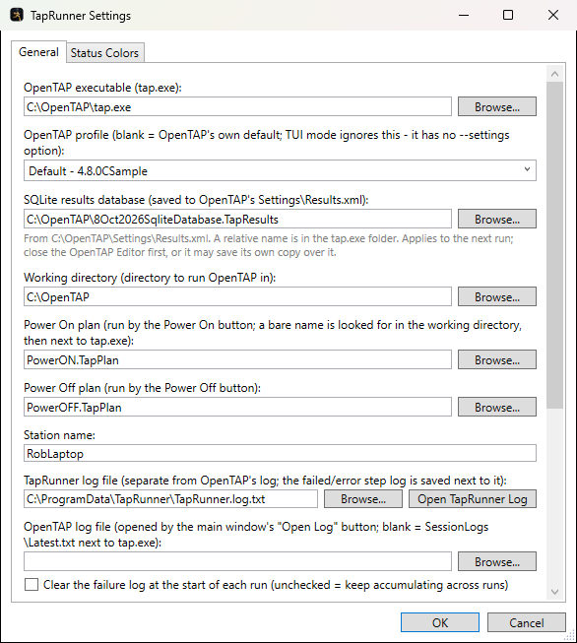
Figure 1 – Settings, General tab

3. A tour of the main window
Figure 2 shows TapRunner as it opens on the station, with PowerON.TapPlan already loaded. The numbers match the table below.
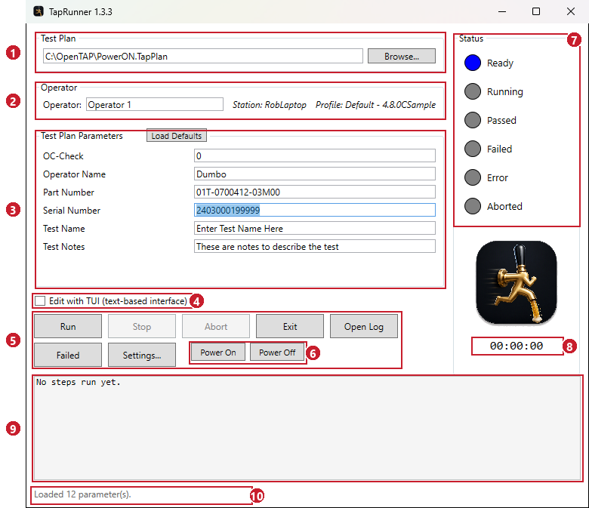
Figure 2 – The main window with PowerON.TapPlan loaded
# | Area | What it is for
1 | Test Plan | The plan that will run. TapRunner reopens the last plan used; Browse… picks another.
2 | Operator | Your name, plus the station name and OpenTAP profile from Settings.
3 | Test Plan Parameters | The plan's operator-editable values. For PowerON.TapPlan: OC-Check, Operator Name, Part Number, Serial Number, Test Name and Test Notes. Load Defaults puts back the saved values from Settings.
4 | Edit with TUI | Opens the plan in OpenTAP's text-based interface instead of running it. The Run button changes to Edit.
5 | Buttons | Run, Stop, Abort, Exit, Open Log (OpenTAP's log), Failed (failed steps) and Settings….
6 | Power On / Power Off | Run the station's power-on or power-off plan in one click.
7 | Status lights | Ready, Running, Passed, Failed, Error and Aborted – see section 5.
8 | Run time | How long the current or last run took.
9 | Step history | Every step as it finishes, with its verdict and results. Holds the last 1,000 steps and can be scrolled.
10 | Status line | What TapRunner is doing now, e.g. the step that is running.

4. Tutorial: run PowerON.TapPlan

Step 1 – Load the plan
If the Test Plan box does not already show C:\OpenTAP\PowerON.TapPlan, click Browse… and open it. TapRunner reads the plan's parameters and lists them in alphabetical order. The status line then shows how many were loaded ("Loaded 12 parameter(s)." for PowerON.TapPlan, of which six are shown and six are hidden – see section 7).

Step 2 – Check who and where
Type your name in Operator. Check that the station and profile shown beside it are right for this bench.

Step 3 – Fill in the parameters
The parameter values start from the defaults saved in Settings (or the plan's own defaults). For each unit:
- Serial Number is already selected when the plan loads, so you can scan the unit's barcode straight in.
- Check Part Number and OC-Check match the unit on the bench.
- Change Test Name and Test Notes if your process asks for them.
Values you type here apply to this run only. To change what a parameter starts at every time, change it under Settings › Default parameter values (section 7). Load Defaults puts every parameter back to its saved value.

Step 4 – Run it
Click Run. TapRunner starts tap.exe, and its console window opens briefly before TapRunner comes back to the front. While the plan runs:
- the Running light is on and the run-time clock counts up;
- Passed flashes for as long as every step so far has passed;
- each step is added to the step history as it finishes, and the status line shows the step running now;
- Run, Browse, Settings and the Power buttons are disabled; Stop and Abort are enabled.
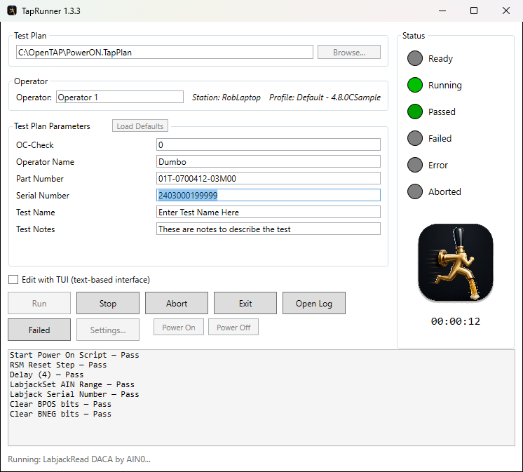
Figure 3 – PowerON.TapPlan running – every step so far has passed

Step 5 – Read the result
When the plan finishes, the light for its final verdict stays on, the clock stops, and the status line says "Run finished: Passed." (or Failed, Error, Aborted). Ready lights again and the buttons are re-enabled for the next unit.
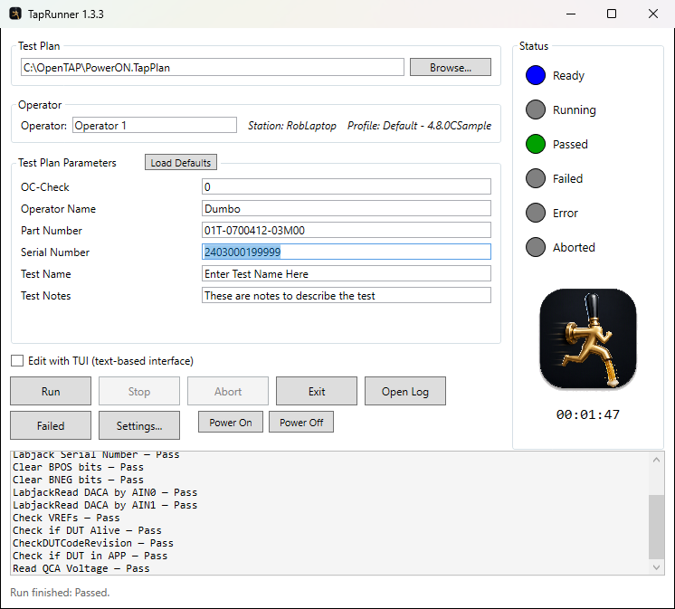
Figure 4 – A finished run with a Passed verdict

Shortcut – the Power On and Power Off buttons
Power On runs the station's power-on plan (PowerON.TapPlan by default) straight away, using its saved default parameter values. You don't need to load the plan first. The plan shown in the main window stays loaded. Power Off does the same with PowerOFF.TapPlan. A plan name without a folder is looked for in the working directory first, then in the tap.exe folder.

5. When a test fails
If a step fails, the Failed light comes on and flashes, and the step history shows which step failed and the results it published. In Figure 5, PowerON.TapPlan's "Check if DUT Alive" step failed, so the run finished Failed.
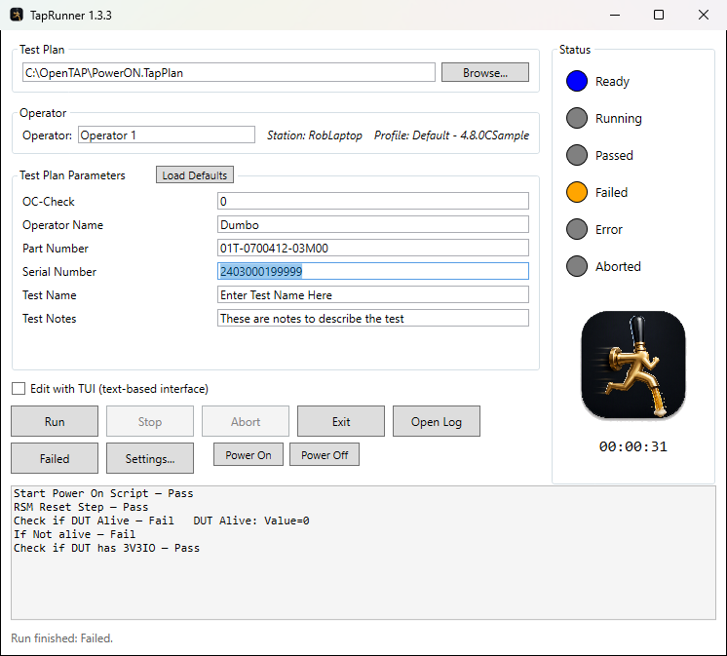
Figure 5 – A run that failed at "Check if DUT Alive"
Click Failed to see just the failed steps, with more detail than the step history (Figure 6). Each run's failures are headed with the plan name and the time the run started. Click Refresh to pick up new failures while a run is still going.
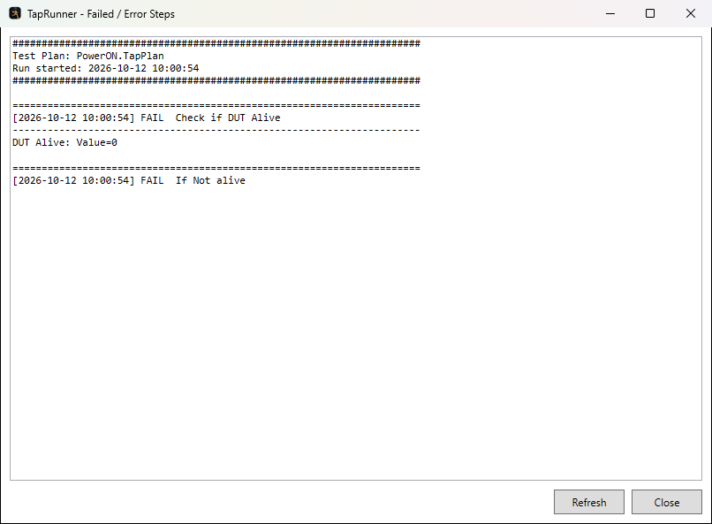
Figure 6 – The Failed / Error Steps window

What the status lights mean
Light | During a run | After a run
Ready | Off. | On – ready for the next run.
Running | On (flashing by default). | Off.
Passed | Flashes while every step so far has passed. | On – the plan passed.
Failed | Flashes while a step failure stands. If a parent step clears the failure (for example a retry that passes), it goes dim and Passed flashes again. | On – the plan failed. Dim – the plan passed, but only after a failure was cleared.
Error | Same as Failed, for steps that end in Error. | On – the plan ended in Error, including when tap.exe stopped without reporting a result.
Aborted | Off. | On – the run was stopped with Stop or Abort.

6. Stopping a run
Button | What it does
Stop | Asks OpenTAP to stop cleanly. The current step finishes and any clean-up steps run, then the run ends as Aborted. Use this one normally.
Abort | Ends tap.exe immediately. Clean-up steps do not run, so the hardware may be left powered or connected. Use it only when Stop doesn't work.
Exit | Closes TapRunner. If a test is running, it asks first and aborts the run if you say yes.

7. Setting up parameters for the station

Default parameter values
Settings › General › Default parameter values (Figure 7) holds a value for each parameter name. These are filled in every time a plan with that parameter loads, and again when you click Load Defaults. A value here always wins over the plan's own default; leave it blank to use the plan's. Copy From Current Plan fills the list from what is in the main window right now. That is a quick way to save a set of values you have just typed in for PowerON.TapPlan.

Hiding parameters
Tick Hidden next to any parameter the operator should not see. PowerON.TapPlan has six parameters that are set once per station and hidden this way: AppMajor, AppMinor, AppSub, PlatformMajor, PlatformMinor and PlatformSub. Hidden parameters are still sent to the test with their saved value. Tick Show hidden parameters greyed out to keep them in the list, dimmed but still editable (Figure 8).
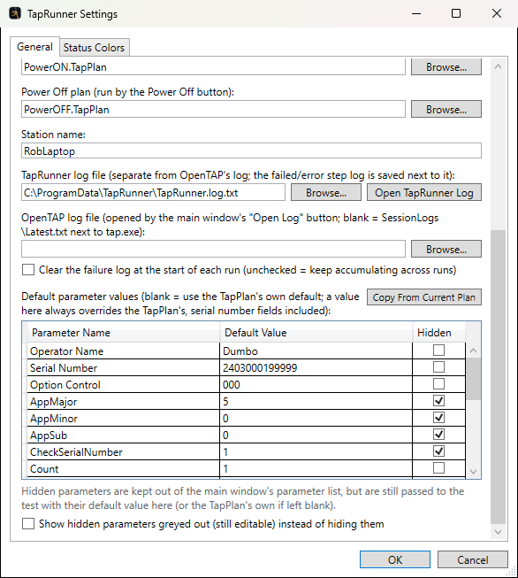
Figure 7 – Default parameter values, with the Hidden column
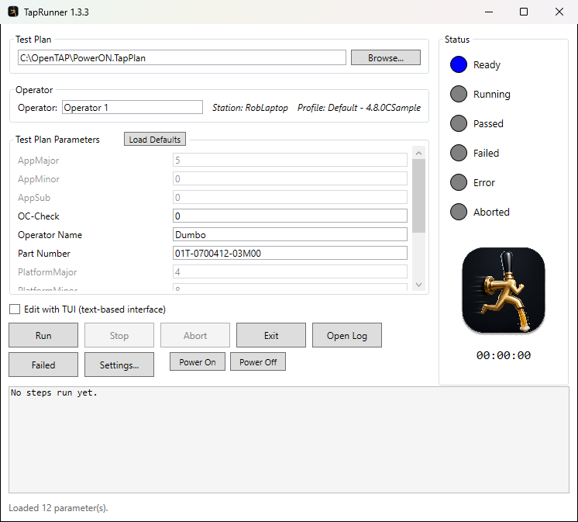
Figure 8 – PowerON.TapPlan with its hidden parameters shown greyed out

Status colours
The Status Colors tab sets the colour of each light, and whether it flashes when fully on. Enter a colour name or a #RRGGBB value.
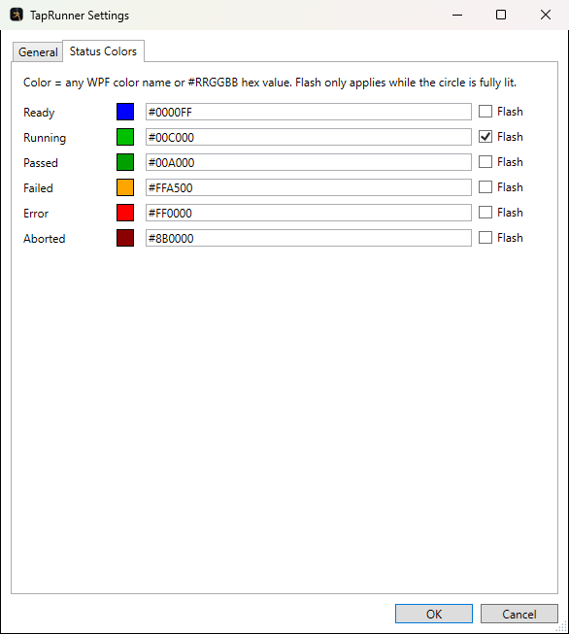
Figure 9 – Settings, Status Colors tab

8. Logs
Where | What you get
Open Log (main window) | OpenTAP's own log of the latest session. It's the most detailed record of what OpenTAP did, including licence and instrument errors.
Failed (main window) | TapRunner's failure log: only the steps that ended Fail or Error, grouped by run.
Settings › Open TapRunner Log | TapRunner's own log: every status message and every finished step, with a timestamp, across all runs.

By default the failure log keeps building up across runs. Tick Clear the failure log at the start of each run in Settings if you only want the current run's failures.

9. Quick troubleshooting
You see | Try this
The lights never change, then "Process exited without reporting a result" | Enable TapRunner Status under Settings › Results in OpenTAP (section 2). If it is enabled, click Open Log and look for a licence or start-up error.
"The configured OpenTAP executable was not found" | Set the OpenTAP executable under Settings.
A parameter you expect is missing from the list | It may be ticked Hidden under Settings › Default parameter values.
Results are going to the wrong database | Check SQLite results database under Settings. Close the OpenTAP Editor before changing it, or the Editor may save its own setting over it.
Power On says the plan was not found | Set the full path to the plan under Settings › Power On plan.

